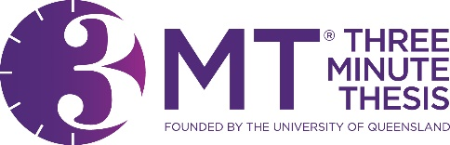**The Chinese University of Hong Kong   
Three Minute Thesis (3MT®) Competition 2025  
Presenter Nomination and Consent Form**

I, the undersigned, as the presenter of the research title consent to participate in the Three Minute Thesis (3MT®) 2025 (Date: 20 May 2025) coorganized by the Graduate School, the Independent Learning Centre, and the Chinese University of Hong Kong Library.

The participation of this competition is nominated by my supervisor  
 , and it is confirmted that the research is **at least two-thirds completed**.

I, the undersigned, agreed that:

1. There will be photographers taking photos and video during the event. Selected photos and edited video (including participants’ presentations) will be uploaded to the library webpages, YouTube channel, and/or other publications.
2. Winners’ research abstracts will be printed on posters and will be exhibited in the University Library (2 June – 30 September 2025), and the New Asia College Ch'ien Mu Library (2 July – 31 July 2025). The award-winning abstracts from the Faculty of Medicine will also be exhibited in the Li Ping Medical Library (2 June – 30 July 2025). The exhibitions will include a monitor to showcase the video of the winners' presentations.
3. My supervisor and all individuals associated with this research project have consented to the presentation of the research at this event as indicated by their signatures below.

**Presenter:**

Name:

Signature: Date:

**Supervisor:**

Name:

Signature: Date:

**Other author(s) of the presented research (if any):**

Name: Signature:

Name: Signature:

Name: Signature:

Name: Signature:

**Organizers**



***Remark:*** *The completed Presenter Nomination and Consent Form should be uploaded to the 3MT Abstract Submmsion Form:* <https://cloud.itsc.cuhk.edu.hk/webform/view.php?id=13704676>